Assessment schedule – 2016
Chemistry: Demonstrate understanding of aspects of carbon chemistry (90932)
Evidence Statement
Q | Evidence | Achievement | Merit | Excellence
ONE  (a) | 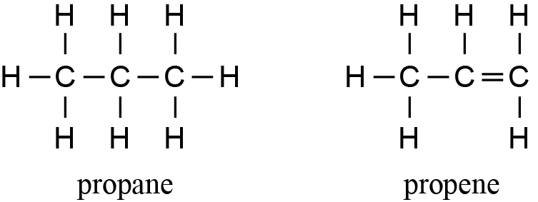 | - BOTH structures correct.
(b)(i)  (ii) | Type of bonding found in propane is covalent bonding.  This is because it is made up of the non-metal atoms C and H, which share electrons. Non-metal atoms share their valence electrons to gain full outer shells, resulting in stable bonds.  Propene has a carbon to carbon double bond, while propane has carbon to carbon single bonds. Thus propene contains two less hydrogen atoms than propane. | - Covalent.  - Describes the bonding in propene (double bond) and propane (single bonds). | - Explains that the non-metal atoms / C and H, share electrons to gain a full outer shell / become stable.  - Links the C to C double bond in propene to fewer hydrogen atoms / unsaturation and C to C single bond in propane to more H atoms / saturation.
(c) | Effects on the environment of two combustion products:  Carbon dioxide gas and water vapour both are greenhouse gases, so they contribute to the greenhouse effect, which leads to global warming due to increased trapping of infra-red radiation / heat and this effects the environment with rising sea levels / melting of polar ice (example). CO₂ is absorbed by the ocean / reacts with water in clouds to form (carbonic) acid and this decreases the pH of the ocean affecting marine ecosystems / causes acid rain which can erode buildings, etc.  Carbon particles can produce visual pollution in the environment, e.g. blackening of limestone walls and monuments as carbon particles are deposited on them, or slow down photosynthesis due to carbon particles coating leaves which prevents entry / exit of gases and water, or carbon particles in waterways affecting fish and plants, etc.  Equation for complete combustion:  C₄H₁₀ + 6½O₂ → 4CO₂ + 5H₂O  Equation for incomplete combustion:  C₄H₁₀ + 5O₂ → 2CO₂ + CO + C +5H₂O  (or any appropriate variation of incomplete combustion, which must include C OR CO AND H₂O). | - States a valid effect on the environment for one product. | - Links a product to an effect on the environment  OR compares availability of oxygen and energy production in incomplete and complete combustion.  - One correct equation with one minor error in balancing. | - Explains effects on the environment from two products.  - Correctly balanced equation for complete combustion.  - Correctly balanced equation for incomplete combustion.

NØ | N1 | N2 | A3 | A4 | M5 | M6 | E7 | E8
No response;  no relevant evidence. | 1a | 2a | 3a | 4a | 3m | 4m | 3e  with minor error | 3e

Q | Evidence |  |  |  |  | Achievement |  |  | Merit |  | Excellence
TWO  (a) | 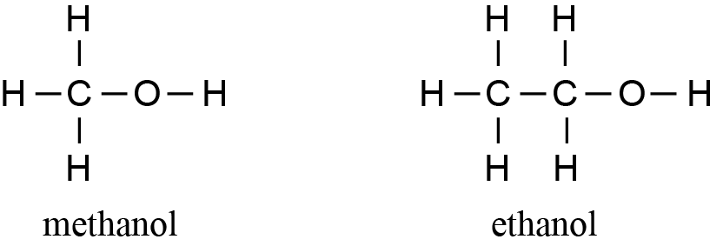 |  |  |  |  | - BOTH structures correct.
(b)(i) | The boiling point of ethanol is higher than methanol, as there is one more carbon atom in ethanol than in methanol, so ethanol has a higher molar mass. As the molar mass increases, the forces of attraction (intermolecular force) between the molecules increase, so more energy is required to overcome these forces to form gaseous ethanol. |  |  |  |  | - Describes larger molar mass / greater number of C atoms / longer chain. |  |  | - Links the greater number of carbons / higher molar mass to increased (intermolecular) forces / forces between molecules (and higher boiling point).
(ii) | Methanol and ethanol are both soluble in water, as they are both alcohols and contain OH groups. The OH groups of the alcohols are attracted to water molecules. The alcohols are more attracted to the water molecules (e.g. methanol – water) than to each other (e.g. methanol – methanol), so they dissolve (accept evidence in a suitable diagram). |  |  |  |  | - States that both methanol and ethanol are attracted to water. |  |  | - Explains that methanol and ethanol are more attracted to water than to their own molecules.
(c) | Methanol is made from methane in a two (or three) step process.  The first reaction is done at high temperatures (over 800ºC) using a nickel catalyst, while the last reaction is done using a Cu-Zn / Cu / Pt catalyst.  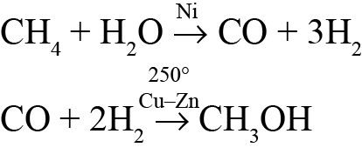  OR  CH₄ + H₂O → CO + 3H₂ (Ni catalyst)  CO + H₂O → CO₂ + H₂  2H₂ + CO → CH₃OH (Cu-Zn, Cu, or Pt catalyst)  OR  2CH₄ + 3H₂O → CO + CO₂ + 7H₂ (Ni catalyst)  CO + 2H₂ → CH₃OH (Cu-Zn, Cu, or Pt catalyst)  CO₂ + 3H₂ → CH₃OH + H₂O (Cu-Zn, Cu, or Pt catalyst)  Ethanol is made by a process of fermentation, which involves the conversion of a solution of sugar molecules (in water) into ethanol and carbon dioxide in warm, anaerobic conditions using yeast as a catalyst. Yeast is a living organism and requires warmth and moisture to carry out fermentation. Yeast metabolises / converts the sugars into alcohol when there is a lack of oxygen.  C₆H₁₂O₆ → 2C₂H₅OH + 2CO₂  How do they differ?  The production of ethanol is a one-step process, whereas the production of methanol involves more than one step.  They both involve the use of catalysts, but to produce ethanol it is yeast, a living organism. To produce methanol, a metal (non-living) catalysts is used.  The production of methanol requires high temperatures, but for ethanol it requires warm and anaerobic conditions. |  |  |  |  | - States heat and Ni and Cu-Zn  OR yeast and anaerobic / warmth.  - Describes methane converted into methanol  OR glucose converted into ethanol. |  |  | - Explains the conditions required for either process, i.e. both achieved points (yeast and anaerobic, and warmth).  - Correct equations for either fermentation or industrial production, but no or incorrect balancing. |  | - Both processes explained correctly including conditions with 1 statement of difference.  - Correctly balanced equations for the production of methanol.  - Correctly balanced equation for the production of ethanol.
NØ |  | N1 | N2 | A3 | A4 |  | M5 | M6 |  | E7 |  | E8
No response;  no relevant evidence. |  | 1 a | 2 a | 3 a | 4 a |  | 3 m | 4 m |  | 2 e  (must include first bullet point, but allow minor omission) |  | 3 e (allow minor omission e.g. condition)

Q | Evidence | Achievement | Merit | Excellence
THREE  (a) | Fractions:  LPG / propane / butane / methane / petroleum gas / CNG – heating / cooking / fuel / transport  Octane / petrol – fuel / transport  Paraffin – heat / light  Naphtha – chemicals  Diesel – fuel / transport  Jet fuel / kerosene – camp fuels / cooking / solvent / aeroplanes / transport  Lubricating oils – engines / waxes / polishing  Heavy oils – fuels / ships / transport  Bitumen / tar – roads / roofs. | - Lists TWO fractions and describes a use.
(b)(i)  (ii) | Crude oil consists of a mixture of hydrocarbon molecules of different sizes, which need to be distilled in order to separate into useful fractions, since the fractions have different uses.  A tower is used because the crude oil is heated and the hot particles rise.  Hydrocarbons of different molecular masses have different boiling points. Larger molecules have higher boiling points. When the heated crude oil vapour enters the tower, the larger, heavier hydrocarbons with the higher boiling points condense into liquids lower down in the tower, while the smaller, lighter hydrocarbons with the lower boiling points rise up the tower and condense back into a liquid at the lower temperatures near the top of the tower. The smallest hydrocarbons (C1 – C4) remain gases at room temperature, and exit from the top of the tower.  This allows the fractions to be separated.  The temperature at which a specific hydrocarbon condenses is related to its molecular mass, particularly the number of carbon atoms. The lower / higher its molecular mass is, the lower / higher the temperature at which it will condense. This determines whereabouts on the tower the particular fraction is collected. | - Describes crude oil as a mixture of different hydrocarbons or alkanes / needing to be separated into parts.  - The separation of the (lighter and heavier) fractions depends on differences in the boiling points. | - Explains that the crude oil needs to be separated into fractions of different length / sized hydrocarbons / alkanes for the fractions to be useful.  - Links the size of the hydrocarbon to where the fraction collects in the tower OR to its boiling point. | - Links the process of fractional distillation (heating, condensing, separating) to the size of the molecules, the temperature at which they change state, and their position of collection in the tower.
(c)(i)  (ii) | 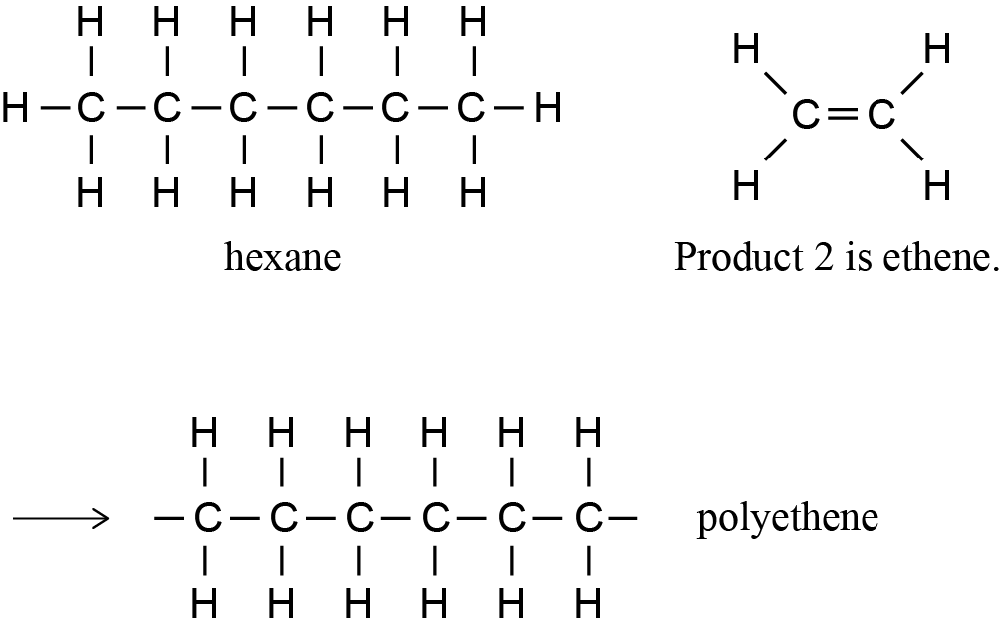  Reaction 1 is cracking. The conditions required are heat, pressure, catalyst.  Reaction 2 is polymerisation. The conditions required can vary depending on the type of polyethene formed – usually high temps / catalyst / pressure.  Polyethene can be made from product 2 (ethene) because alkenes contain a C=C. The C to C double bond can be broken during polymerisation, and carbon atoms from adjacent molecules can then form single bonds between them, forming long chains of carbons.  Evidence for C to C double bonds and carbon atoms can come from a correct diagram on page 8 or 9. | - THREE out of four names / structures correct.  - Reactions 1 and 2 are correctly named  OR  describes conditions for either reaction 1 or 2  OR  states that a carbon to carbon double bond is required. | - Explains that a carbon to carbon double bond is required so it can be broken to form new single bonds / to enable many monomers to join together and form a long chain / polymer. | - Gives the conditions required for both reactions, and explains why a carbon to carbon double bond is required for polymerisation (bolded points included).

NØ | N1 | N2 | A3 | A4 | M5 | M6 | E7 | E8
No response;  no relevant evidence. | 1 a | 2 a | 3 a | 4 a | 2 m | 3 m | 2 e with minor omission | 2 e

Cut Scores
Not Achieved | Achievement | Achievement with Merit | Achievement with Excellence
0 – 7 | 8 – 12 | 13 – 18 | 19 – 24

